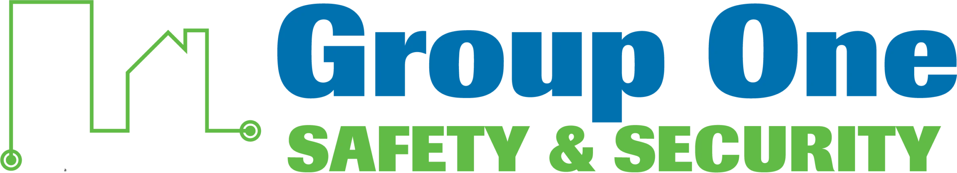
Client Relationship Representative
Inside Sales & Account Growth | $28–$35/hr.
Location: St. Lucie, Martin, Palm Beach & Broward Counties
Employment Type: Full-time, Exempt
Reports To: Branch Manager (Stuart)
Pay: $28–$35/hr., based on experience

Group One Safety & Security is looking for a Client Relationship Representative to manage inbound sales opportunities, turn prospects into long-term clients, and grow existing accounts. This is an inside role for someone who’s organized, customer-focused, and comfortable juggling proposals across fire sprinkler, fire alarm, CCTV, access control, and intrusion systems. If you like being the person clients trust to get them an answer, you’ll do well here.
What You’ll Do
- Respond promptly to inbound sales inquiries and convert qualified prospects into clients.
- Prepare and deliver proposals for repairs, upgrades, and new system installations.
- Identify upsell and cross-sell opportunities within existing accounts, recommending system upgrades, expansions, and service enhancements.
- Review deficiency reports from field technicians and inspectors and prepare corresponding repair and upgrade proposals.
- Coordinate with operations to ensure proper scoping and pricing accuracy.
- Provide basic troubleshooting assistance and direct clients to the right department for service issues.
- Maintain accurate, up-to-date CRM records for all client interactions and opportunities.
- Support client satisfaction and retention initiatives.
What We’re Looking For
- 2+ years of experience in inside sales, customer service, or account coordination — fire, security, or life safety industry preferred.
- Strong understanding of fire and security systems, including fire sprinklers, fire alarms, CCTV, access control, and intrusion/burglar alarm systems.
- Highly organized and detail-oriented, able to manage multiple priorities and deadlines.
- Excellent verbal and written communication skills with a customer-first mindset.
- CRM proficiency (NetSuite experience a plus).
- Ability to read and interpret deficiency reports, proposals, and technical documentation.
- Proficiency in Microsoft Office Suite.
- High school diploma or equivalent; degree in business or a related field a plus.
What We Offer
- Competitive pay based on experience
- 401(k) retirement plan
- Paid time off, holidays, and sick days
- Ongoing training and professional development
- Stable, locally owned company with 40+ years in the community
About Group One Safety & Security
Group One Safety & Security has been South Florida’s trusted name in life safety and security since 1984. Locally owned and operated, we’ve grown from the Treasure Coast to serve clients from Orlando to Miami — protecting homes, high-rises, hospitals, HOAs, and industrial facilities with fire alarm, fire sprinkler, security, access control, and video surveillance systems. We have a saying here: “Do it right and do the right thing.” That starts with hiring the right people.
Ready to Apply?
Submit your resume and a brief note about your experience to be considered. Qualified applicants will be contacted to schedule an interview. All candidates must be able to pass a pre-employment background check and drug screening.
Group One Safety & Security is an Equal Opportunity Employer. Employment decisions are based on merit, qualifications, and abilities. We do not discriminate on the basis of race, color, religion, sex, national origin, age, disability, sexual orientation, gender identity, veteran status, or genetics.

